**SUBMITTED BY**

**FULL NAME:** Gaurav Shakya

**COURSE:** BTEC HND in Computing

**SEMESTER:** First Semester

**SECTION:** C

**YEAR OF ENROLLMENT:** 2018

**SUBMITTED TO**

Mr. Sushil Bhattarai

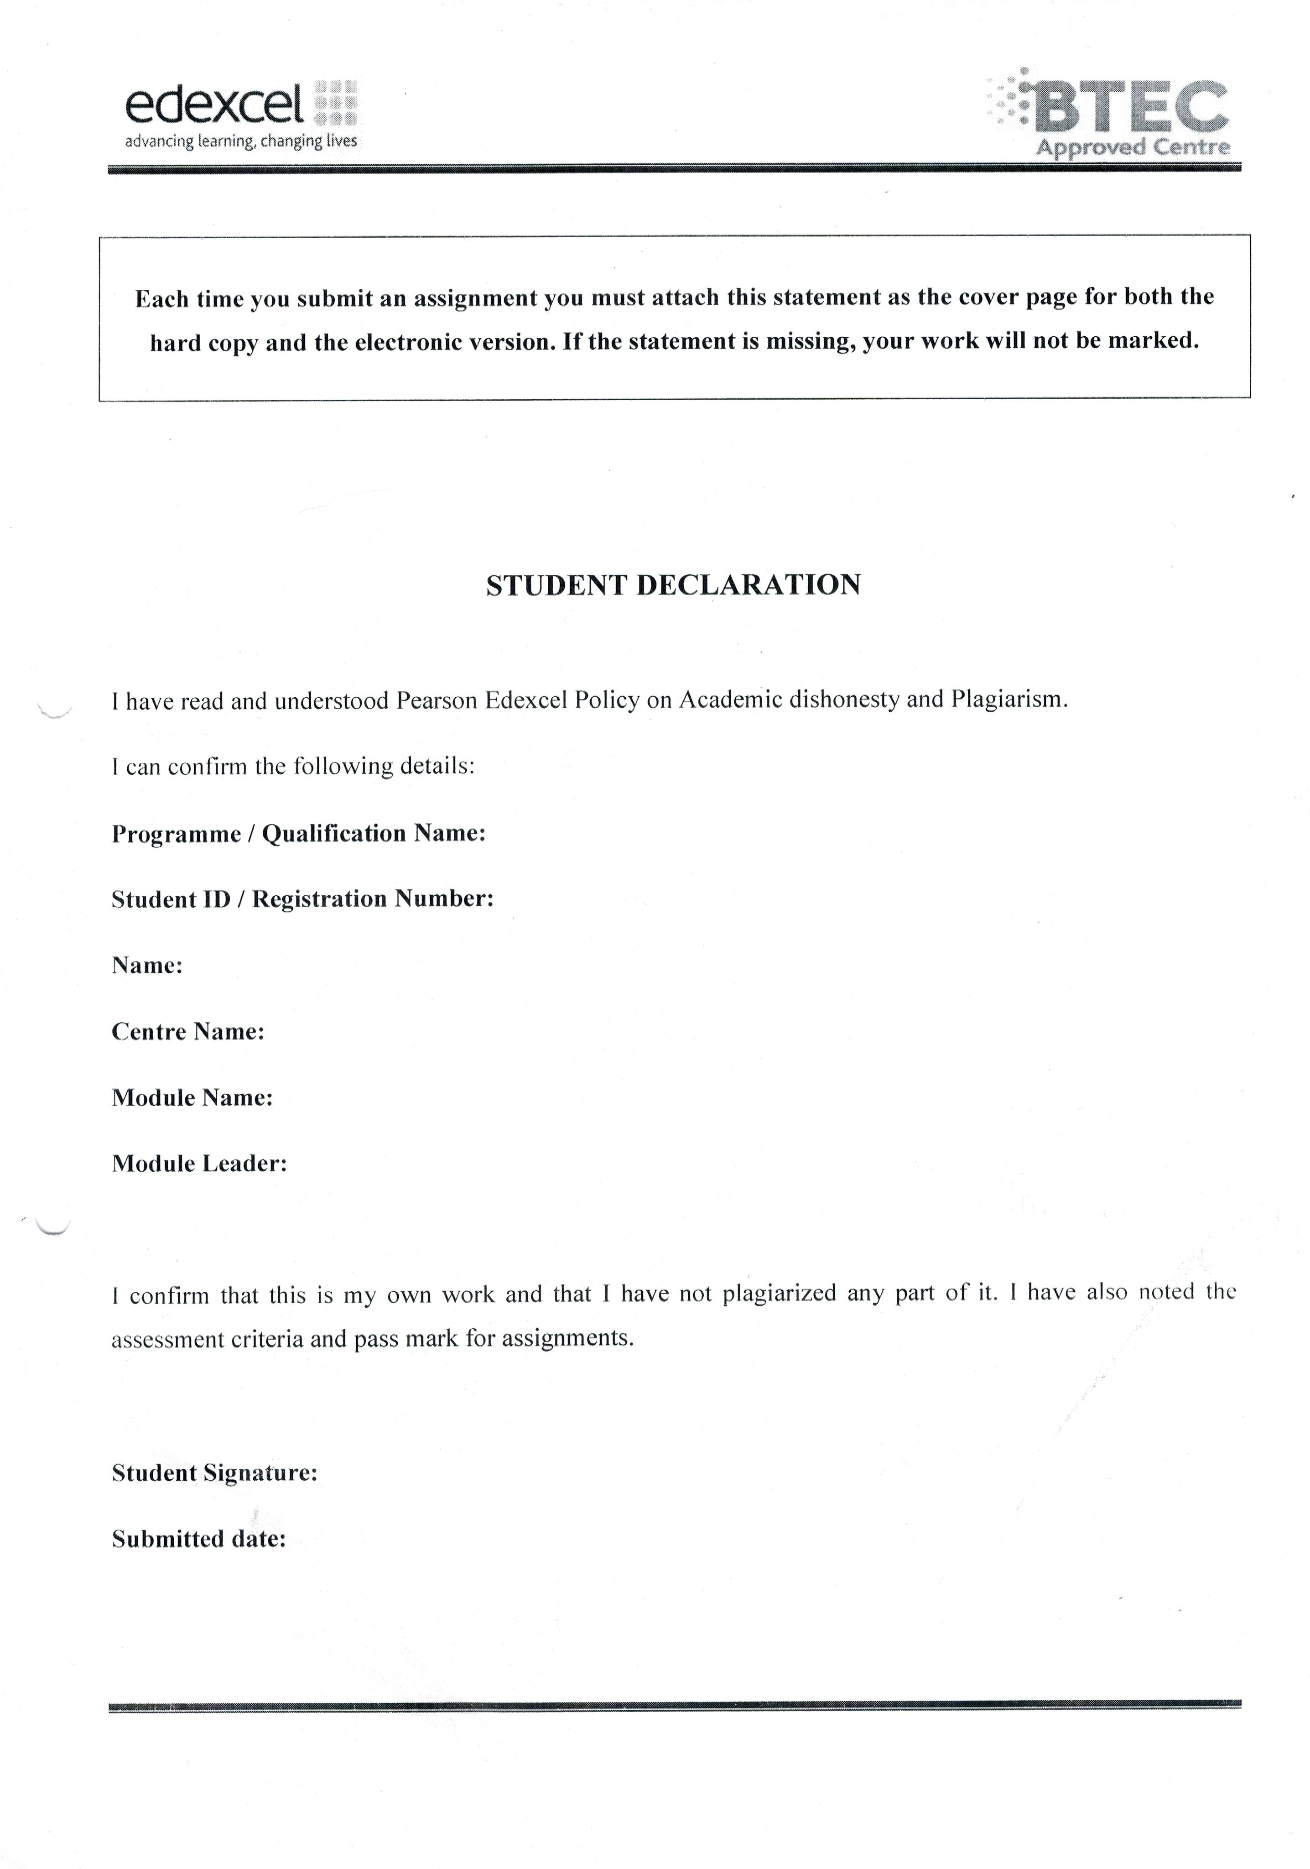

**Table of Contents**

Part 1 3

Introduction 3

Choice of tools:- 4

Entity Relationship Diagram:- 5

Data Dictionary:- 7

Implement fully functional system 9

Data Normalization 12

System Requirements 14

User Requirements:- 15

Conclusion 16

Part 2 17

Introduction 17

Implement Necessary Constraints 17

Evidence of user interface and data validation 18

Implement System Security 20

Implement T-SQL (Transact-SQL) Programmability features 21

Implement query language into the relation database system 23

Reports 30

Conclusion 35

Part 3 36

Introduction 36

Testing 37

User Documentation 40

Flowchart 50

Conclusion 56

# Part 1

**Before you start the development process, your manager has asked you to produce a report for the CEO of the given company, containing:**

**1. The design of the relational database system using appropriate design tools and techniques. It should contain at least four interrelated tables. 2. Clear statements of user and system requirements. You would prefer to produce a more detailed document, so you will produce a comprehensive design for a fully functional system which will include interface and output designs, data validations and cover data normalization.**

**Your manager would like a separate report on your assessment of the effectiveness of the design in relation to user and system requirements.**

## Introduction

A database structured to recognize relations between stored items of information which is organized by tables, records and columns is known as relational database. Five interrelated tables named – Customer, Order, Order Item, Product, Supplier are used in my project. Included more detailed document such as Place Order, Reports, and many more. Use of Snapshot of required details for effectiveness of project, including data validation, and data normalization.

Since the data are repeatedly Inserted, Updated, Deleted, Save, so there must be valid data. By practicing simple data validation rules, databases are more consistent, functional and provide more value to their users. I will be applying data validation as when the user inputs incorrect Username and Password it will show error message. Similarly, null value input in must needed entity like Name, Address, it shows error message and when the users inputs same data in the table like Product should not be repeated.

Data Normalization is a technique of organizing the data in the database i.e. it organizes the tables in a manner that reduces redundancy and dependency of data. It divides larger tables to smaller tables and link them using relationships.

## Choice of tools:-

I have used SQL server 2014–express edition for Relational Database Management System. As it is used because SQL Server organizes all objects, such as tables, views, and procedures by database names, also, it can be used for small projects as well as large applications and can handle millions of transactions per day.

In this project for IDE (Integrated Development Environment), I have used Visual Studio – 2017 Community Edition as I found this tool very easy and convenient including many features. I choose C# using .Net Framework as programming language. Visual Studio is good platform for everyone with any OS (Windows, Mac or Linux). The main reason behind why I used Visual Studio is that it is easy to Edit, Build and Debug. As I have been using this tool, I found that it provides auto-option, bracket-matching, box-selection and many more. There is also an easy Keyboard shortcuts, which helps us in code, also consumes less time.



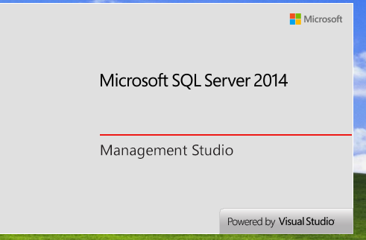

# **Entity Relationship Diagram**:-

Customer

Order

Places

Order Item

Includes

Product

Sells

Supplier

User

An Entity Relationship (ER) diagram is a graphical representation of how ‘entities’ are related to each other within a system. They are generally used to design and debug relational databases. Entity can be a single person, place, or thing about which data can be recorded. Each entity has a set of properties which is known as attributes. ER diagram uses a pre-defined set of symbols such as rectangle, oval, diamond, and connecting lines. Here, in out ER diagram,

|  |  |
| --- | --- |
| Entity | Entities, which are represented by rectangles shows an object or concept about which you want to store information. For example, Customer, Supplier, Product in given ER diagram. |
| Action | Actions, which are represented by diamond shape shows how two entities share information in the database. Example, Customer place and order place are related, so place is Action Entity. |
|  | Attributes, which are represented by oval shapes is a unique characteristic of the entity. For example, Customer’s attribute may be his first name, last name. |
|  | This connection line means one to one entity. |
|  | This connection line defines one to many, means Customer can order many orders. |

When documenting a system or process, looking at the system in multiple ways increases the understanding of that system. ERD diagrams are commonly used in conjunction with a [data flow diagram](https://www.smartdraw.com/data-flow-diagram/) to display the contents of a data store. They help us to visualize how data is connected in a general way, and are particularly useful for constructing a relational database.

## Data Dictionary:-

As the given Scenario, I have assigned different data dictionary like One Id column, foreign key, Primary Key with Identity Property in each table as necessary.

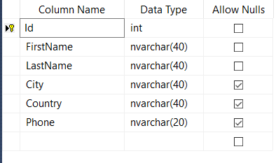This is Customer Table. I have used primary key in Column ‘Id’ so that all the record will be unique and automatically increase.

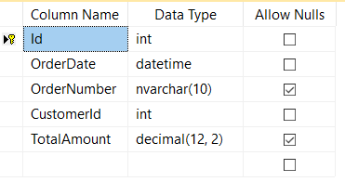This is Order table. Again, I have used primary key in column ‘Id’. Foreign key used in ‘Customer Id’, as foreign key helps to refer the column of another table having Primary key. Here, ‘Customer id’ is linked with ‘Id’ of Customer table.

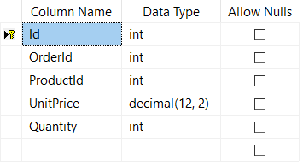

This is Order Item table, and used Primary key in ‘Id’, Foreign Key in ‘Order Id’ and ‘Product Id’ to join with Order Table’s ‘Id’ and Product Table’s ‘Id’ respectively.

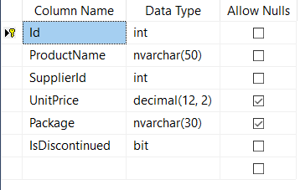

This is Product table, where ‘Id’ is primary key, and ‘Supplier Id’ is foreign key.

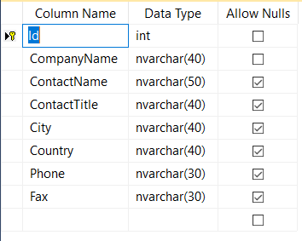Here, this is Supplier Table whereas ‘Id’ is primary key.

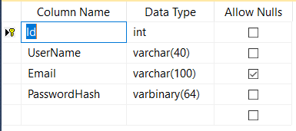

This is User table, where the Username and Password is taken from.

## Implement fully functional system

Snapshots of input and output forms:

**Input:-**

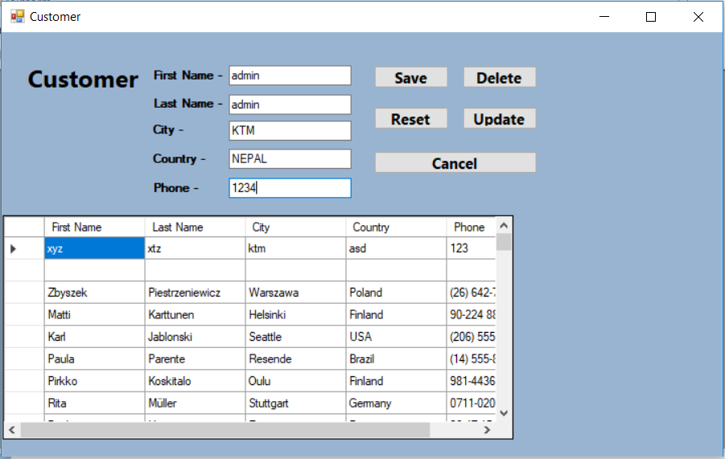You can see the given input such as First Name, Last Name, City & Country, and Phone of Customer to customer table in Visual Studio which is going to be store in Database too. Here, I hid the Id because it is not necessary to show in the form.

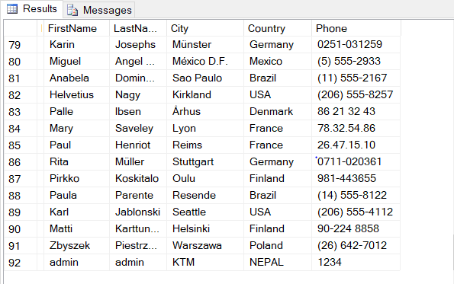**Output:-**

Here, the output is showed, message box with “Saved.” And on the right side, data stored in SQL server.

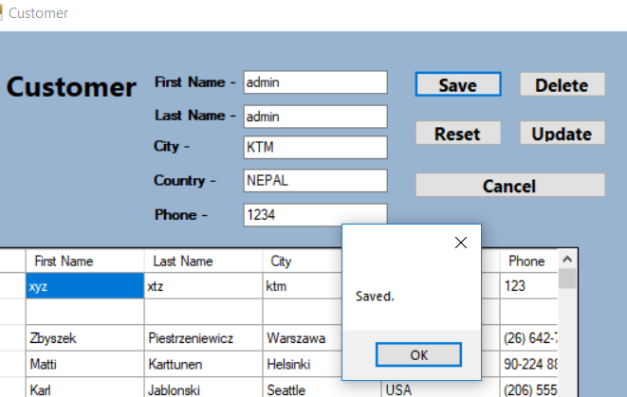

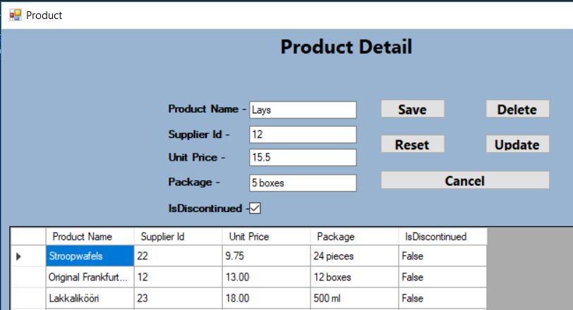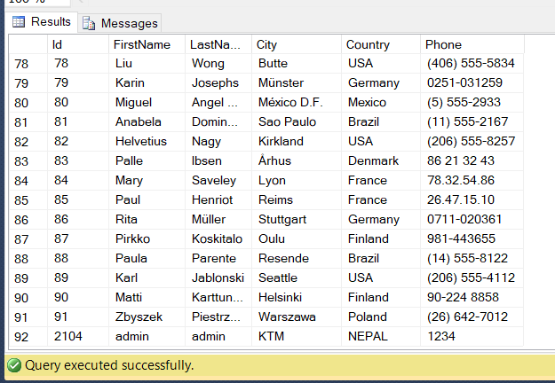**Input :-**

Here, the data are entered for Product table such as Product Name, Supplier Id, Unit Price, Packages, and Is discontinued of the Product.

**Output:-**

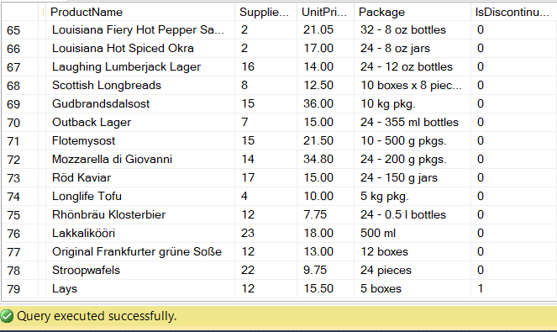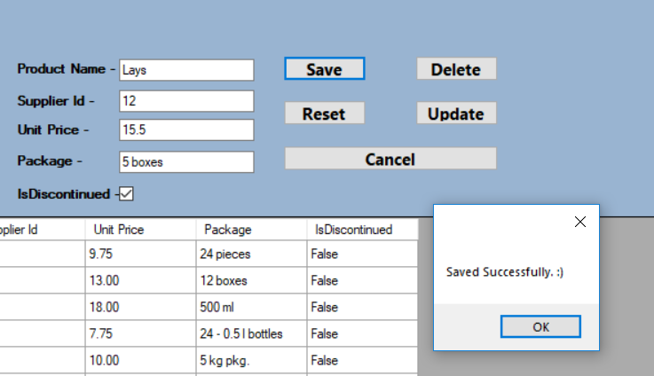Following snapshot shows the output of Product, data stored in SQL server and a message box without error.

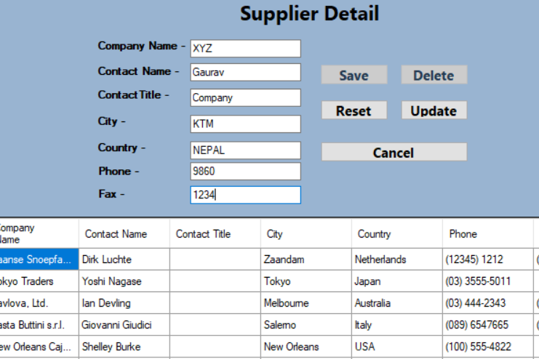**Input:-**

Input for the Supplier details.

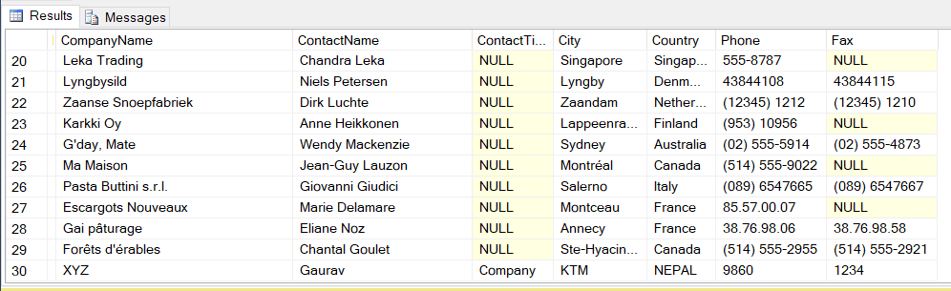

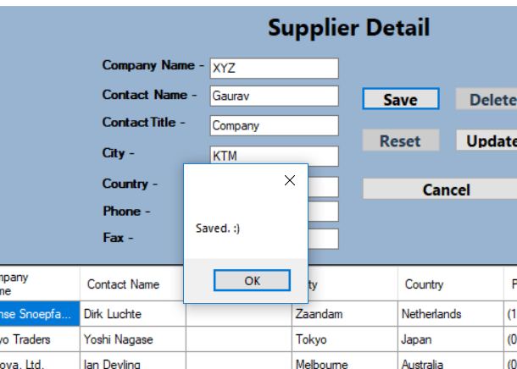**Output:-**

You can see upper one is the output in database SQL server.

And right one is output in message box.

## Data Normalization

Normalization is a technique of organizing or managing the data in the database. Normalization is a systematic process of breaking down tables to decrease data redundancy (repetition).

Without any normalization, all information is stored in one table as shown below.

|  |  |  |
| --- | --- | --- |
| **Name** | **Address** | **Subject** |
| **Gaurav Shakya** | **KTM** | **Programming** |
| **Sumit Shakya** | **KTM** | **Database** |
| **Rikit Shakya** | **KTM** | **Network** |

**1NF (First Normal Form) Rules:**

Here, in 1NF (First Normal Form) rule, each able cell should contain a single value and each record should be unique. Example:

|  |  |  |  |  |
| --- | --- | --- | --- | --- |
| **First Name** | **Last Name** | **City** | **Country** | **Subject** |
| **Gaurav** | **Shakya** | **KTM** | **NEPAL** | **Programming** |
| **Sumit** | **Shakya** | **PKR** | **NEPAL** | **Database** |
| **Rikit** | **Shakya** | **LTL** | **NEPAL** | **Network** |
| **Gaurav** | **Shakya** | **KTM** | **NEPAL** | **Software** |

**2NF (Second Normal Form) Rules:**

In 2NF, again I split the tables, using foreign key.

|  |
| --- |
| **Student** |

|  |  |  |  |  |  |
| --- | --- | --- | --- | --- | --- |
| **ID** | **First Name** | **Last Name** | **City** | **Country** | **Subject** |
| **1**  **2**  **3**  **4** | **Gaurav**  **Gaurav**  **Sumit**  **Rikit** | **Shakya**  **Shakya**  **Shakya**  **Shakya** | **KTM**  **KTM**  **PKR**  **LTL** | **NEPAL**  **NEPAL**  **NEPAL**  **NEPAL** | **Programming**  **Software**  **Database**  **Network** |

|  |
| --- |
| **Subject** |

|  |  |
| --- | --- |
| **Subject** | **Student Id** |
| **Programming** | **1** |
| **Software** | **1** |
| **Database** | **3** |
| **Network** | **4** |

**3NF (Second Normal Form) Rules:**

Again to move my 2NF table into 3NF**,** again I need to again divide our table.

|  |
| --- |
| **Student** |

|  |  |  |  |  |  |
| --- | --- | --- | --- | --- | --- |
| **ID** | **First Name** | **Last Name** | **City** | **Country** | **Subject Id** |
| **1**  **2**  **3**  **4** | **Gaurav**  **Gaurav**  **Sumit**  **Rikit** | **Shakya**  **Shakya**  **Shakya**  **Shakya** | **KTM**  **KTM**  **PKR**  **LTL** | **NEPAL**  **NEPAL**  **NEPAL**  **NEPAL** | **1**  **2**  **3**  **4** |

|  |
| --- |
| **Course** |

|  |  |
| --- | --- |
| **Subject** | **Student Id** |
| **Programming** | **1** |
| **Software** | **1** |
| **Database** | **3** |
| **Network** | **4** |

|  |  |
| --- | --- |
| **Student Id** | **Subject Id** |
| **1** | **1** |
| **1** | **2** |
| **3** | **3** |
| **4** | **4** |

System Requirements**:-**

System requirements defines the configuration that a system must have for a hardware or software, application to run smoothly and efficiently. Incase these requirements are not met, there might be failure of installing the software or performance problems. Performance can differ from different computers, laptops according to their System. As I used SQL-Server 2014 for the database storage and for IDE I used Visual Studio 2017, here are the following requirements for it.

**Requirements in SQL Server:**

* Operating System – Windows 7 or above.
* Memory – (Minimum – 1 GB) & (Maximum – at least 4GB)
* Processor – (x86 Processor – 1.0 GHz), (x64 Processor – 1.4 GHz), (Recommended – 2.0 GHz or faster.
* Hard Disk – SQL server 2014 requires minimum of 6 GB space. For better performance use more than 20 GB of Hard disk.

**Requirements in Visual Studio:**

* Operating System – Windows 7 or more.
* Memory – (Minimum – 2 GB) & (Maximum – at least 4GB or more)
* Processor – 1.8 GHz or faster processor.
* Hard Disk - (Minimum – 50 GB) & (Maximum – at least 130 GB depending on features installed.)

Note: Always use computers on which there is NTFs file format. It is most secured file system. Also, use windows 8 or above for better performance.

## User Requirements:-

User Requirements means what the Software, Application expect user to be able to do. You can see the snapshot on the right which is Login Form, where Users are required to Log In with their Username and Password, only Administrator has rights to provide New Account. That means new Users should contact Administrator for their Sign Up.

Clicking in + sign, administrator can Create New Users.

User should provide their Username, Email and Password accordingly.

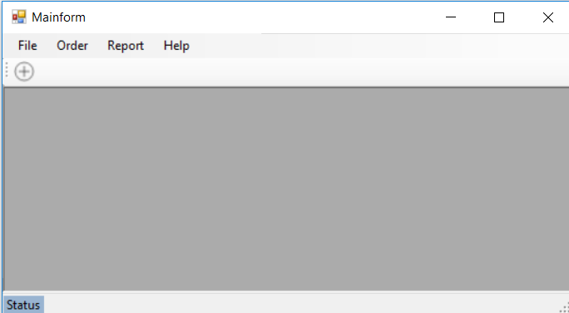

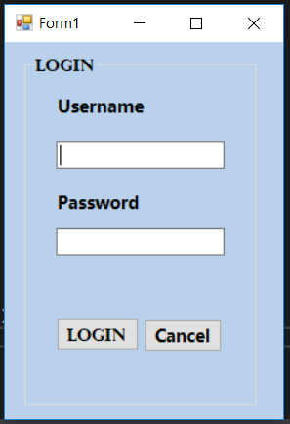

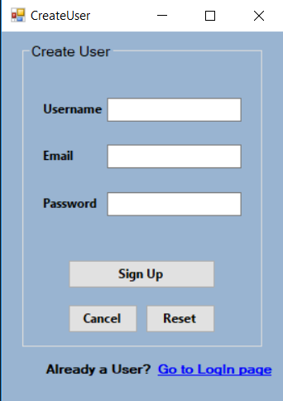

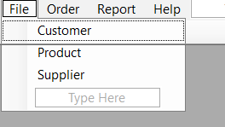**Tables:**

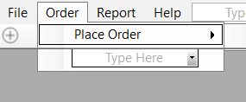

In our project, a customer (from Customer Table) can places orders on the product (from Product table) that are being supplied from the Supplier table. One Customer can place many orders and one Supplier can supply many products. All the table includes one Primary key for column name ‘Id’. In Customer table, customer should provide their details such as First Name, Last Name, City, Country and Phone. Similarly in order table, it includes the Order detail like Order Date, Order Number, Customer Id (Foreign Key) and Total Amount. In table; Order Item, it contains details of Order Item as Order Id (Foreign Key), Product Id (Foreign Key), Unit Price and Quantity of the product. Product table is for details of Product which includes Product Name, Supplier Id (Foreign Key), Unit price and Package of the product and Is Discontinued. Likewise, Supplier table shows where the supplies are taken from, that comprise Company name, Contact name, Contact title, City, Country, Phone and Fax. Finally, table User includes Username, Email and Password for Login where the create user page is linked with.

## Conclusion

Hence, I have covered all the required context. Designed the relational database system using Visual Studio – 2017 Community Edition tool and SQL server. Included fully functional system including interface and design of outputs. Applied data validations for better and error-less project with data normalization for easier review. Ended with most importantly, User requirements and System requirements.

# Part 2

**Once the designs have been accepted by your manager you have been asked to develop the database system using evidence of user interface, output and data validations and querying across multiple tables.**

**You want to include more than just the basics so you will implement a fully functional database system which will include system security and database maintenance features.**

**\*You have decided to implement a query language into the relational database system. * The developed system will be demonstrated to your manager. * Your manager has asked you to produce a report including the followings: 1.Assessing whether meaningful data has been extracted through the use of query tools to produce appropriate management information. 2. Evaluating the effectiveness of the database solution in relation to user and system requirements, and suggest improvements.**

## Introduction

As this is part 2, I developed the database system using evidence of user interface, output and data validations and querying across multiple tables. For the security, I have used encrypted password in database and prevented SQL injection as well. Calling stored procedure helps in preventing SQL injection. I will be keeping the snapshot of the query(Insert, Update, Delete and many more) I have used for the project, validation error when the password is incorrect.

Using necessary constraints in the required table like Primary key, Unique key, Foreign Key, many more.

Implement Necessary Constraints**:-**

**Primary Key –** A primary key is a special relational database table column designed to uniquely identify all table records. Its main features are: it must contain a unique value for each row of data and it cannot contain null values. Database automatically generates a unique number each time a data is added, and all null values are also automatically rejected. In our project, I have used Primary Key especially in ID of each table. I have already showed and described the Constraints in part I.

**Foreign Key –** Foreign key is a key used to link two tables together by referring the Primary Key in another table. The table containing the foreign key is called child table, and the table containing candidate key is called parent table. For example, if there are two table, customer and order, a relationship can be created between them by a foreign key into order table that refers to the customer ID in the customer table. The customer ID now exists in both the tables. The customer ID in the order table becomes foreign key, referring primary key in the customer table. To insert an entry into the order table, foreign key constraint must be satisfied, i.e. if there is no customer ID in customer table, attempt of entering data fails.

**Unique Key –** Unique key is a set of one or more than one fields/columns of table that ensures all the value in a column are different or not. Here, both the Unique and Primary key provides guarantee for uniqueness of a columns. Primary key itself has a Unique Constraint.

**Not Null Key –** Basically, a column can hold Null values, thus, Not Null key/constraints compel a column to not to accept Null values. If the value is null in this column that means you cannot insert a new record or update. I have used Not Null Key in important column name such as First Name, Last Name, Phone, Country,

## Evidence of user interface and data validation

|  |  |
| --- | --- |
| Following snap is Login page, since I have given incorrect password, it throws error and couldn’t open the application. | This is form to create new users, Al the data are required here. So, empty Email box shows an error. |
|  |  |

Since Company name in this table is must, and the field is empty, it won’t save.

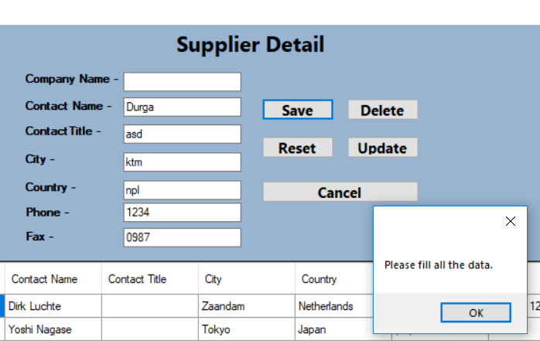

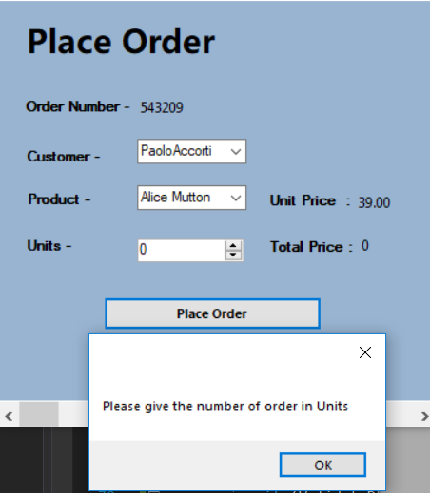In the following snapshot below, I can’t place the order unless the number of order is specified.

Implement System Security**:-**

**Windows Authentication -** Windows authentication means that SQL Server validates a user's identity using only his Windows username and password. If the user has already been authenticated by the Windows system, SQL Server does not ask for a password. If this mode is chosen, SQL server disables the SQL server – specific login functionality.

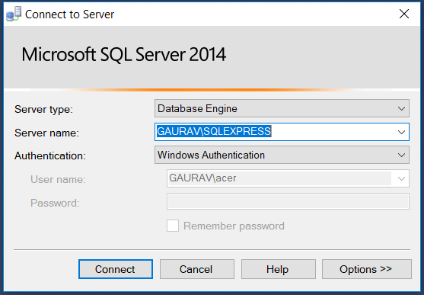As you can see, when I selected Windows Authentication, the username and password is not required to connect to SQL server.

**SQL Server Authentication:-**

When using SQL Server Authentication, logins are created in SQL Server that are not based on Windows user accounts, that means, both the username and the password are created by using SQL server and stored in it as well. Users connecting using SQL Server Authentication must provide their login and password every time they join.

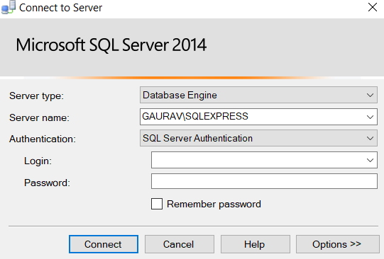Following snapshot is example of SQL Server Authentication, as we need Login and Password to connect.

Three following optional password policies are available for SQL Server logins:

* **User must change password at next login** – This ability is provided by SQL Server Management Studio.
* **Password expiration** – The maximum password age policy of the computer is given for SQL Server logins.
* **Password Policy** – This includes password length and complexity. The password should be strong including at least eight character long, symbols (@, #, $, %), numeric value, upper case letters.

Implement T-SQL (Transact-SQL) Programmability features**:-**

* **Stored Procedure –** A stored procedure is a prepared SQL code that you can save, so the executing code can be reused again and again at any time. So, if you write a Procedure, and says executed successfully, you can just call it to execute it. You can also pass parameters to a Procedure. It prevents SQL injection too. By using Procedure, hackers cannot inject our SQL server**.** The following snapshot is the example of Stored Procedure with a parameter passing. Date1 and Date2 are the parameter where the program is executed between certain date of time.

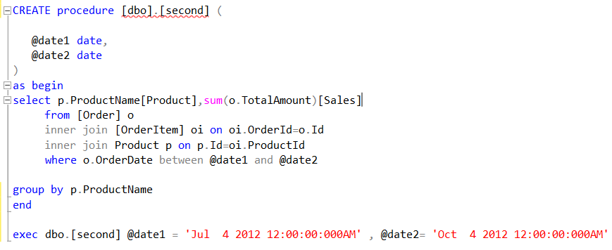

**Backup and Restore Plan:-**

Backup is a storage of data i.e. the exact copy of the data in different disks or storage devices. So, if the original data is lost, we can recover it. There are two types of Backup:

* **Physical Backup –** These are the backups of the physical files used in storing and recovering database. It stores database information to disk or other storing devices. It also provides the minute details about the transaction and modification of the database.
* **Logical Backup –** It includes backup of logical data likes views, procedure, functions, tables, etc.

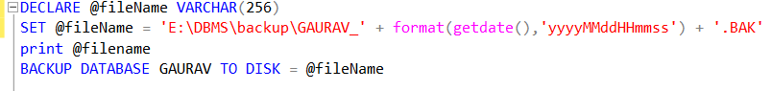Example of Backup in SQL.

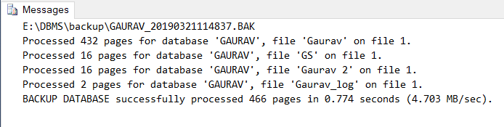 Message box showing files that are backup.

Implement query language into the relation database system**:-**

In our project – Visual Studio, I made a Class named ‘Dbconnection’ so that it could be easier to call it in every form. It will be easy and fast to code.

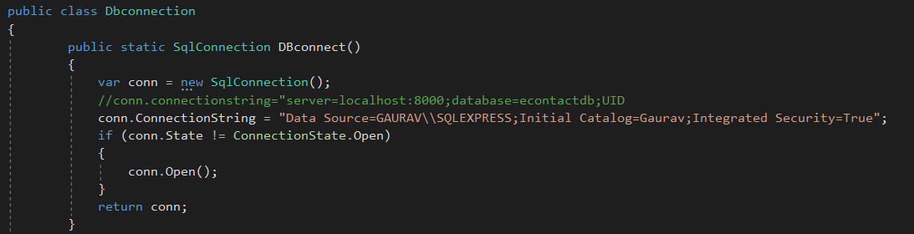In the following snapshot, SqlConnection represents an open connection to a SQL Server Database. It is used when I have to connect the project to SQL Database and open the Connection State.

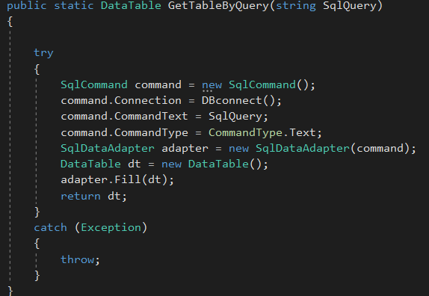Here, following Class is used when I have to show the data in the form of table like Data Grid. Data Table represents in one table of in-memory data. SqlCommand represents a T-SQL statement or stored procedure to execute against SQL Server Database. SqlDataAdapter represents a set of data commands and a database connection used to fill the DataSet. Try and Catch represents the error handling, we can find where the error is.

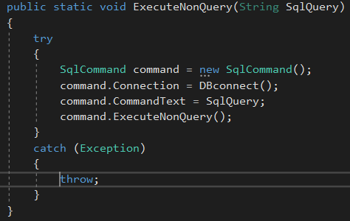ExecuteNonQuery class is applied when we have to execute a SQL statement or stored procedure from SQL Server database.

**Query used in application:**

Here, the following statements are for Customer, Product, and Supplier table:

**Select Statement:** Select query is used to select all the data from the respective table from SQL Server and displays it in data grid.

**Insert Statement:** This query stored/save the data to the SQL Server. I have used this in save button in the application**.**

**Update Statement:** Update query is used in Update button to update/edit the existing data.

**Delete Statement:** Delete query deletes the data from database. It is used in delete button.

* **Customer Table**

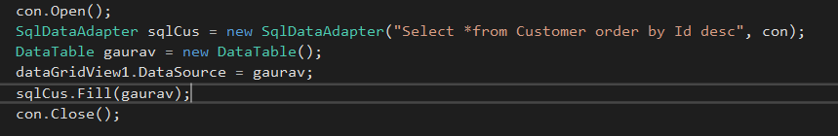**Select Statement:** I have used this query to select all the data from the Customer table (In descending order by Id) which is stored in SQL Server that displays it in data grid view.

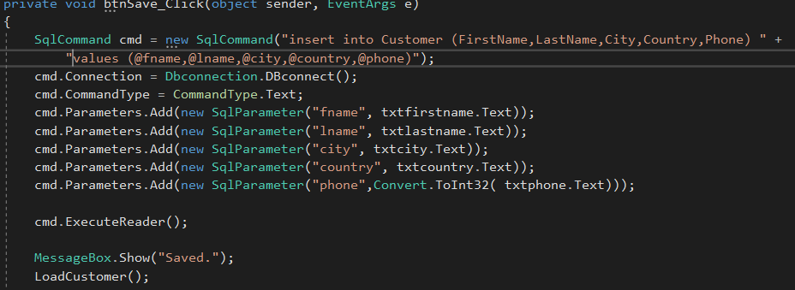**Insert Statement:**

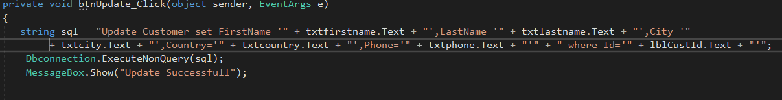

**Update Statement:** Update query is used in Update button to update/edit the existing data.

**Delete Statement:** Delete query deletes the data from database. It is used in delete button.

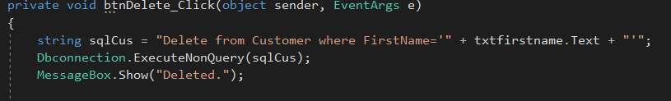

* **For Product Table**

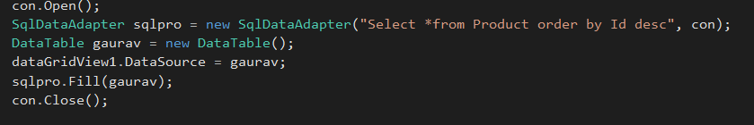**Select Statement:**

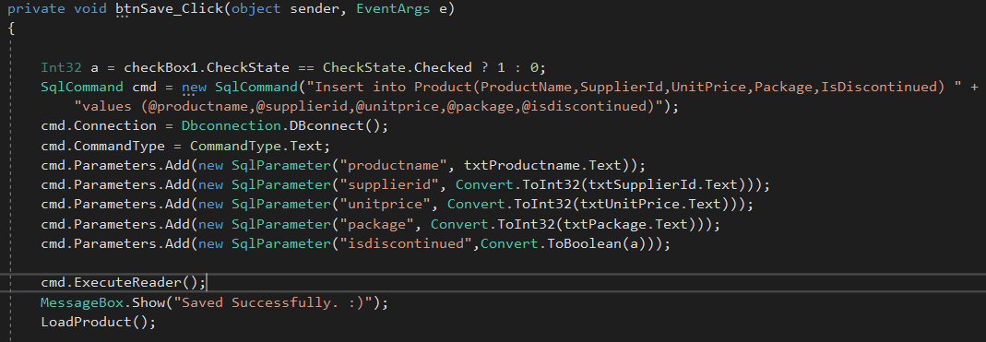**Insert Statement:**

**Update Statement:**

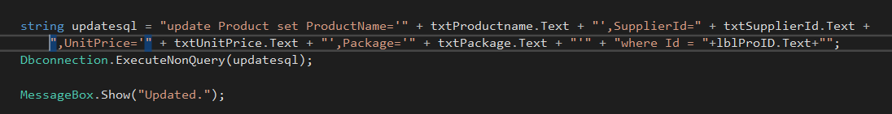

**Delete Statement:**

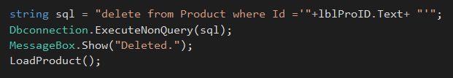

* **For Supplier Table**

**In Visual Studio:**

Select Statement:

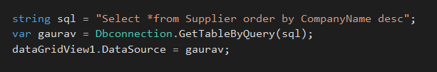

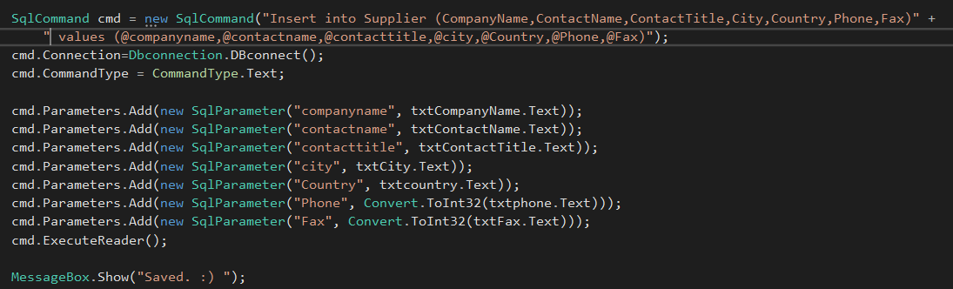Insert Statement:

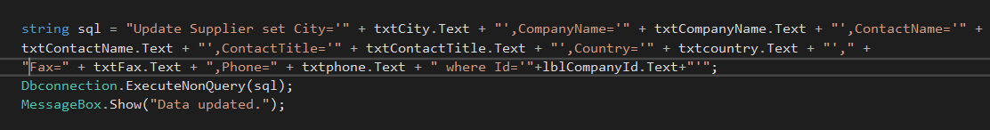Update Statement:

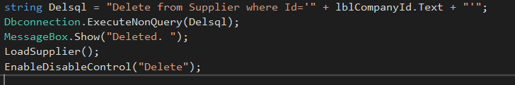Delete Statement:

* **Place Order (Order Table)**

**Insert Statement** – Insert query is used in button ‘Place Order’ that place the order of the Customer (stores the information that is ordered)

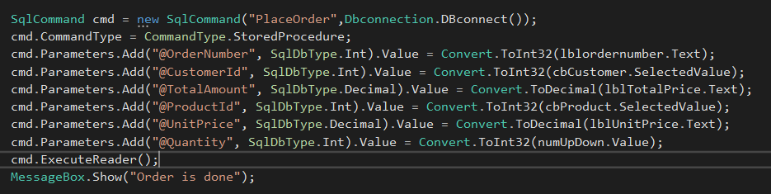

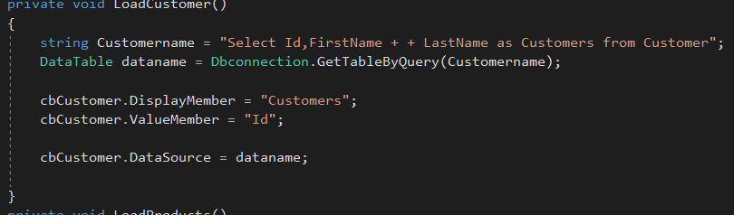 Following Select statement is used to select all the Customer name to display it in combo box so that Customer would select their respective name to place the order.

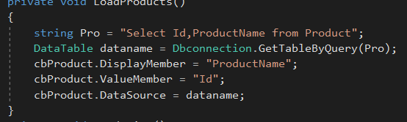 Following query helps to display the all the Product Name to combo box. This assists Customers to select the Product to Order it.

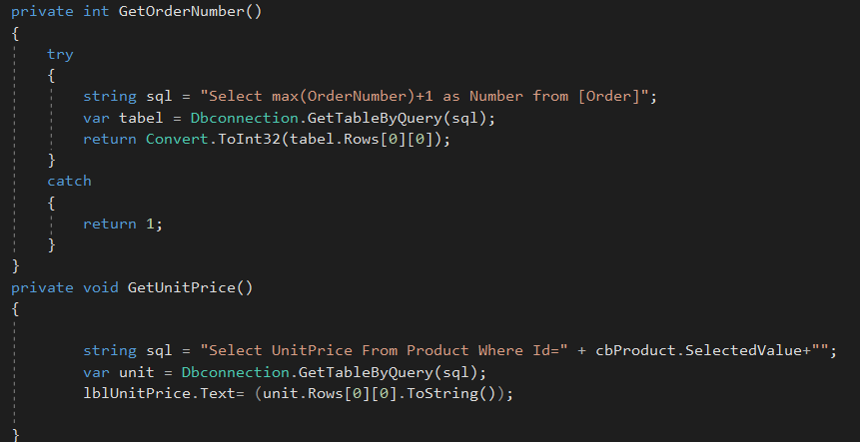 Following Select query selects the Order number and add 1 on the new order, which means it stores a unique Order number.

This is used in displaying the price of the selected product.

Reports**:-**

* 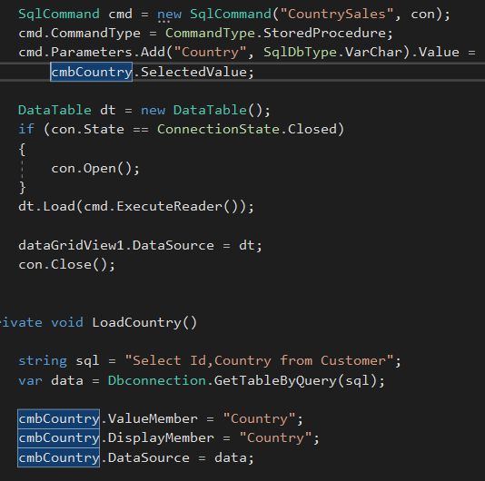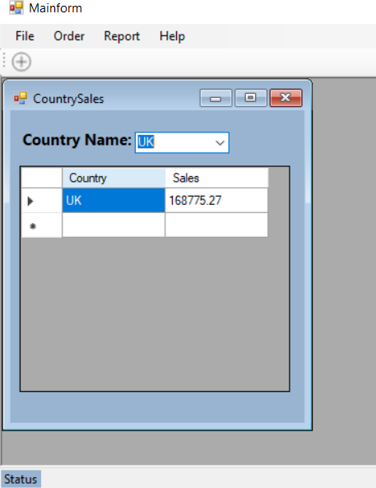**Total Sales in a specific Country:**

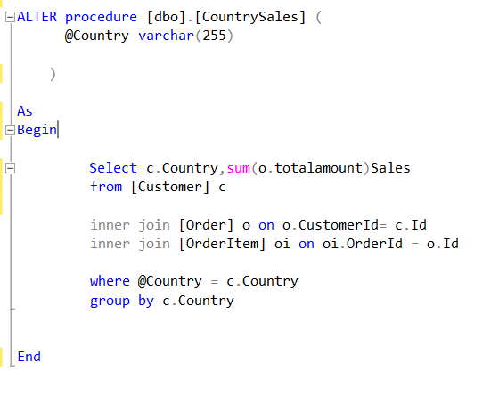

Here is the snapshot of the Procedure where I called it.

* 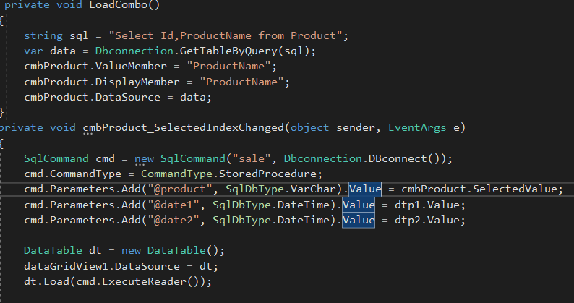Product wise report for total sales within a range of date.

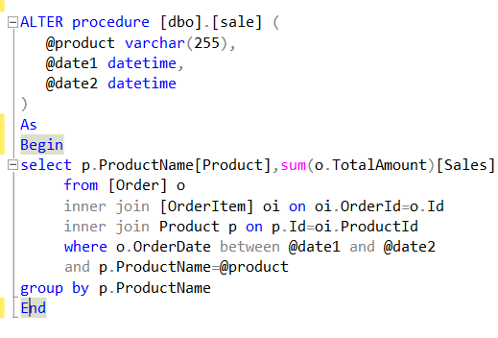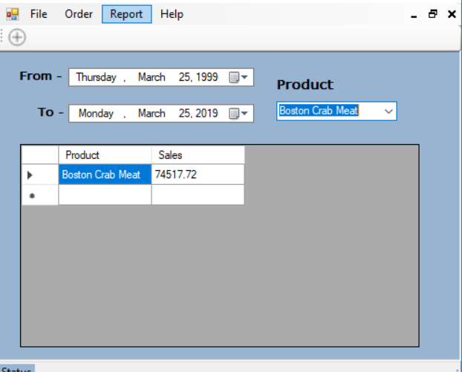 Procedure called from database.

* 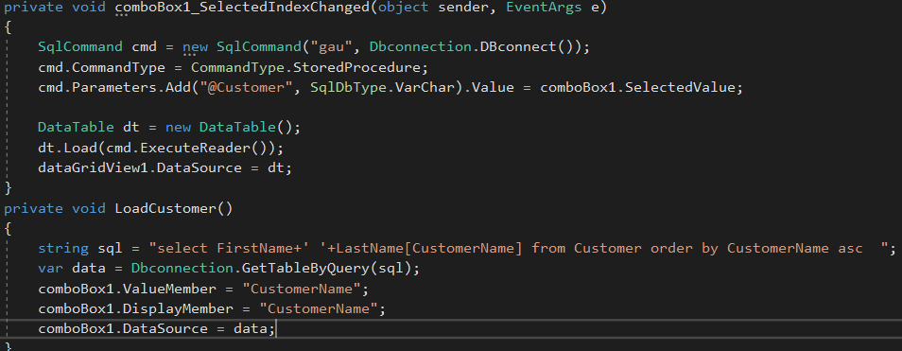Customer wise report of ‘date of purchase’ and ‘total purchase’

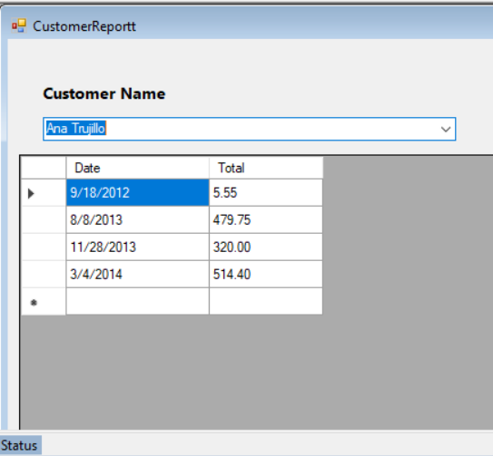

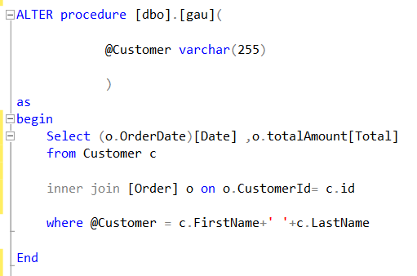Stored Procedure:

* Year wise report to show Customer Name and Number of Orders.

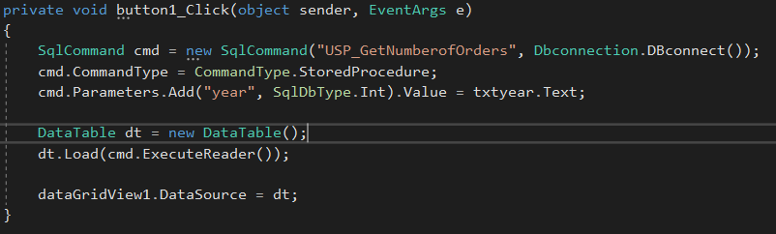

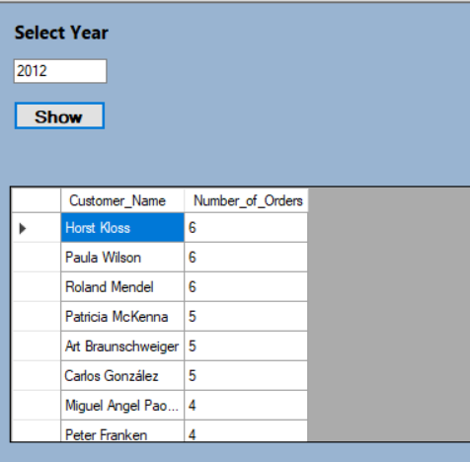

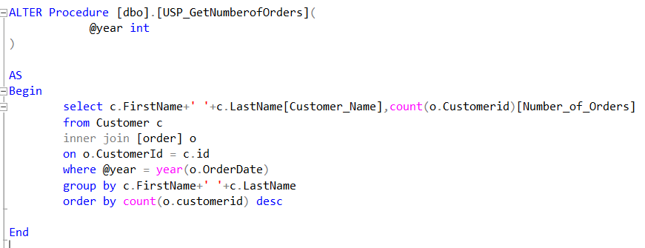Procedure called:

* Product wise report showing Total sales with taxes.

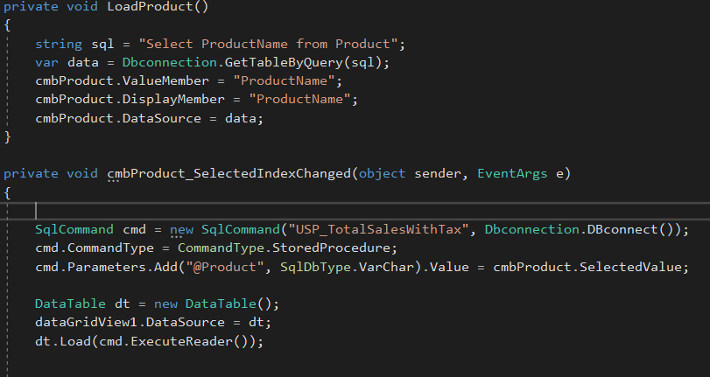

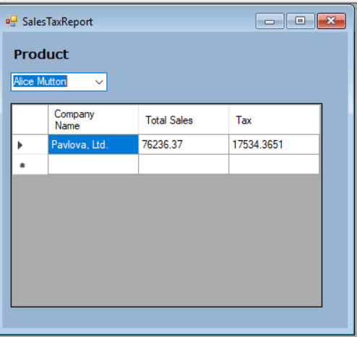

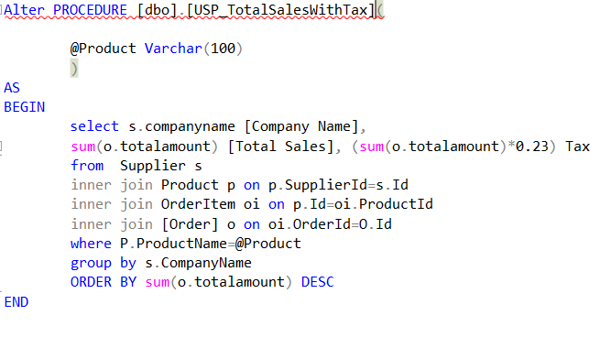

Procedure called:

**\***Evaluating the effectiveness of the database solution **in relation to user and system requirements.**

So, I also finished our Part II section. I am evaluating my database solution in respect to user and system requirements. We know that, this project is about International Vendor existing many clients over the globe. This vendor needed an application to store data on the products that has been bought from any of its Suppliers and Customers located in different countries that could make orders on these Products.

Here, Customer are now able to place the order on the product that are being supplier from the Supplier with no difficulties. Due to data validation, empty data cannot be stored where the data is must like Address, Phone, Name, etc. Customer will not face any problem, if any, testing portion can be helpful, what is to be changed or required. If he/she is a new user than administrator should login and create a new user. After that, he/she could be able to login with his/her Username and Password provided. Applying Unique will decrease the rate of data repetition, so in various table.

This application will be much helpful for Customer to use. I have made it simple and convenient. Many people around the World could place the order for their required Product in a second. No any Computer language is necessary to run this program. Also, I have used Enable Disable function, this means Enabling and Disabling some of the button when not necessary. For example, when the Forms are visited Delete, Reset, and Update button are disabled because there it is not necessary; it is enabled automatically when needed. Finally, step by step user documentation is given by me to understand if any problem.

## Conclusion

Hence, I have finished part II. In this part, I have developed the application showing User Interface, Output and Data validations and querying across multiple tables. This is the part where I show all the queries I used, apply data validation, applying security system and many more. I have decided to implement the query language into the relational database system. All the developed system have been demonstrated to my manager.

Also, I have produced a reports of the Application like Report of total sales within a Country, and many more. Similarly, I evaluate the effectiveness of the database solution to user and system requirements and provided little suggestion for the further improvement of the application.

# Part 3

**Once the system has been developed, you will test the system and your manager will complete a witness statement indicating how your tests are performing against user and system requirements. 2. You will produce a brief report assessing the effectiveness of the testing, including an explanation of the choice of test data used. 3. Lastly you will produce technical and user documentation which will be given to the company. 4. You want to provide some graphical representations for ease of reference in the technical guide, so you have decided to produce a technical and user documentation for a fully.**

## Introduction

Since I have completed task 1 and task 2 with all the requirements needed for the application with many features like data validation, data normalization, maintaining security and other which will make the application to run smoothly and conveniently.

In this last part, I will be discussing about the how the users can use the program, i.e. User Documentation. I am also testing the application against user and system requirements that include White box and Black box test. Similarly, I will include diagrams showing the movement of data through the system and flowcharts describing how they works. Every system must be upgraded or updated with some improvements. Also, testing such as Unit test, Black box and White box are done. So, last but not the least, I am suggesting some future improvements that may be required to effectiveness of the database system.

Testing**:**

|  |  |  |  |  |
| --- | --- | --- | --- | --- |
| **S.N** | **Test Date** | **Test Description** | **Expected Output** | **Actual Output** |
| **1.** | 10th March | Login Form | Users logging with correct and validate Username and Password should directly go to Main form (MDI form). | Expected output. |
| **2.** | 11th March | Sign Up Form | Compulsion of strong password and Validate data. | Expected output. |
| **3.** | 12th March | Customer Form | Input details of Customer without empty and invalidate data. | Expected output. |
| **4.** | 14th March | Product Form | Input valid Product details without empty data. Unique key required in product name. | Expected output. |
| **5.** | 16th March | Supplier Form | Doesn’t stores empty data and invalidate data. | Expected output. |
| **6.** | 17th March | Place Order | Any Customer should place order any product. Order should not be placed if any of the input box is empty. | Expected output. |
| **7.** | 18th March | Sales Report | Result of total sales done within a certain date range. | Expected output. |
| **8.** | 20th March | Supplier Report | Result of Product Name, Date of Purchase with total sale from Customer Name. | Expected output. |
| **9.** | 21st March | Country Sales Report | Result of Total Sales in a Specific Country. | Expected output. |
| **10.** | 24th March | Order Report | Number of orders with Customer Name in selected Year. | Expected output. |
| **11.** | 25th March | Sales with Tax Report | Results of Company name, total sales and tax with given Product Name. | Expected output. |

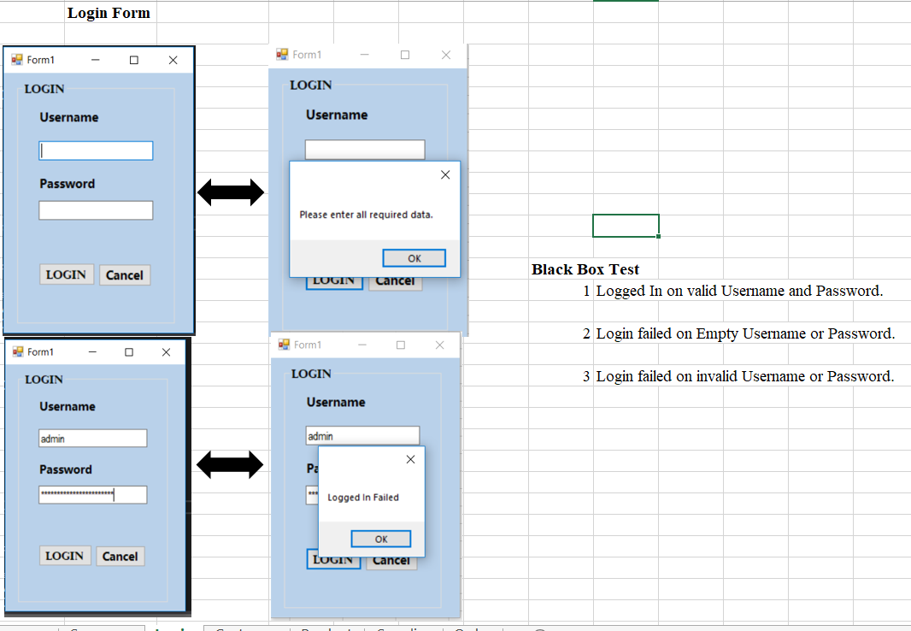

**Software testing** is testing of your software done to verify that the completed software package functions according to the expectations defined by the requirements/specifications. There may be some bugs, error, and it handles situations that could negatively impact the customer, usability and/or maintainability. It checks what all functions in software supposed to do & also check that Software is not doing what he not supposed to do.

I have used Microsoft Excel for the test.

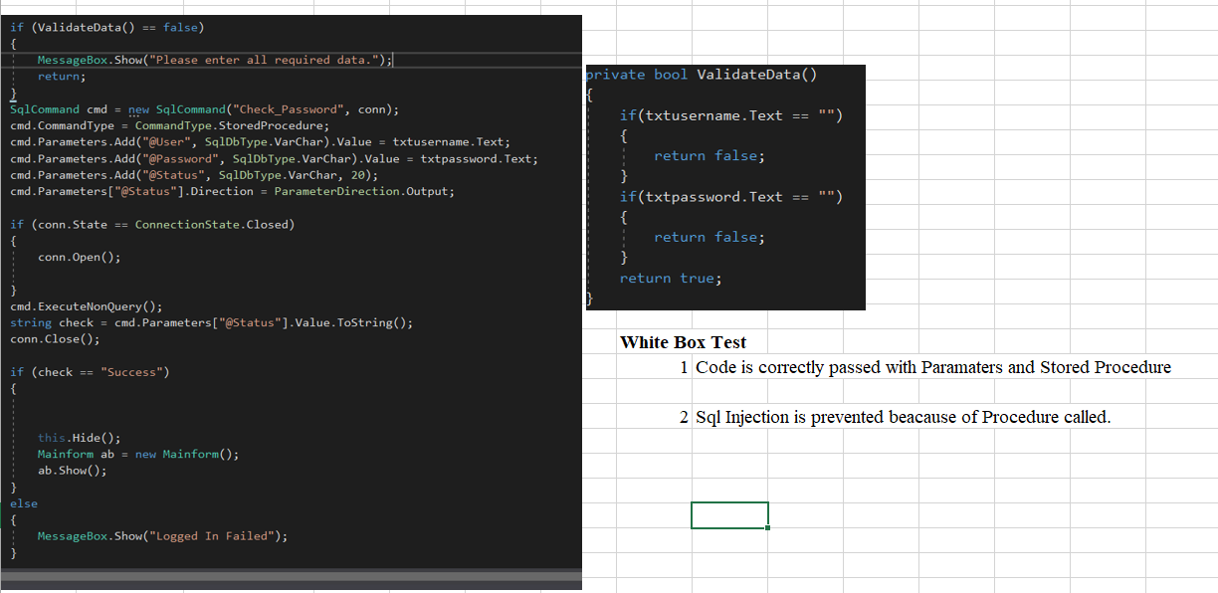

**\*Producing a technical and user documentation for a fully functional system, including diagrams showing movement of data through system and flowcharts describing how the system work.**

User Documentation**:**

First of all, open this file named ‘Loginform’ to open the application.

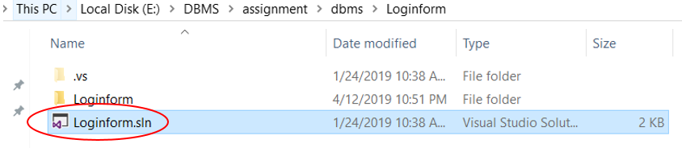

**This login form will open.** 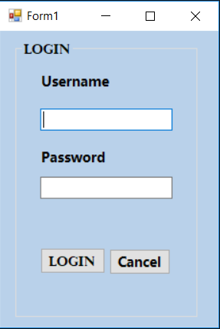

**1)** Enter your valid Username.

**2)** Enter your Password.

**3)** Click Login to open the Main form.

**4)** Click Cancel to Exit.

Note: If you don’t have any account here, please contact

Administrator.

Here, the data are assigned from the table of database where

all the Username and Password are saved.

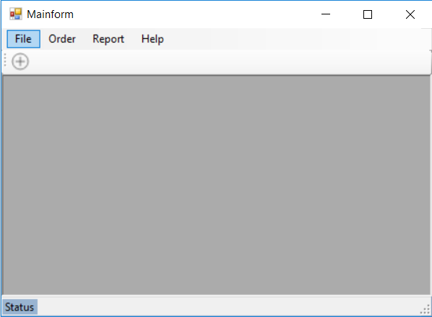

*This form will pop-up after the login with valid Username and Password.

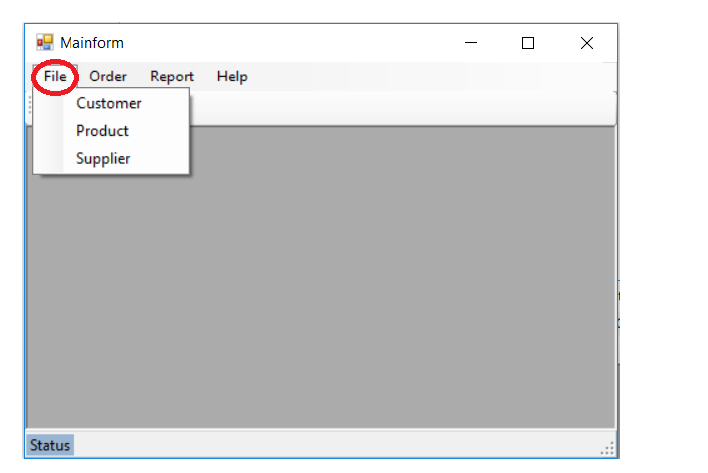**\***Expand >>File, for following tables.

**You should give your details in Customer table to place the order from your name.**

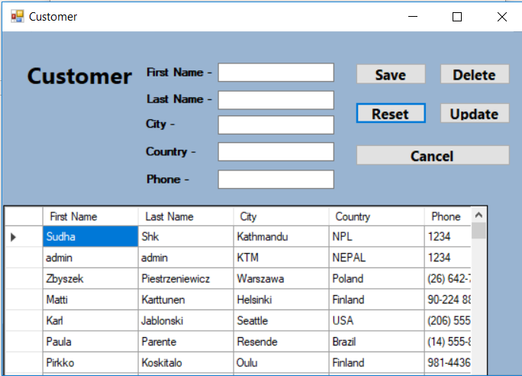**1)** Before clicking Save button, fill all the data, if not, it will display an error due to data validation.

**2)** Reset button clears all the data in the boxes.

**3)** First double click the row in the data grid you wanted to delete as shown in figure below and click Delete button to delete the data. Here, it deletes data by its Id number, which I have made invisible in the form.

**4)** Double click the specific row in data grid, update the data and to apply, click Update.

**5)** Cancel to return to close the data.



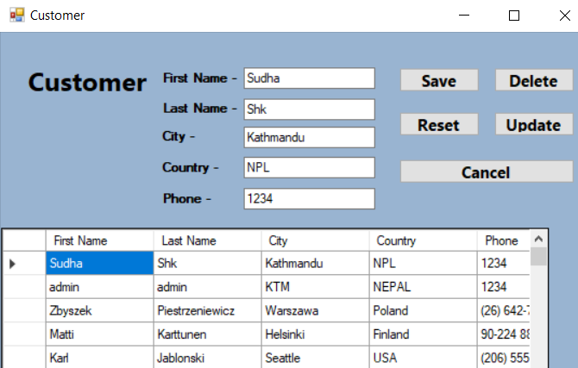

Here, all the data are saved to, deleted and updated from database table ‘Customer’.

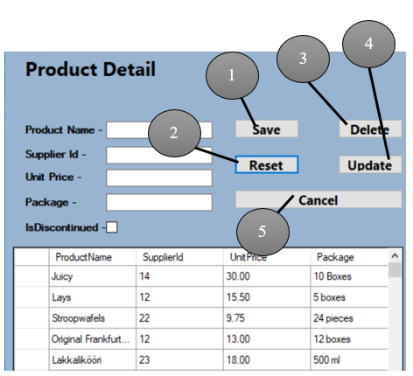

**In this Product table, I made Product Name as a Unique Key, so that the Products will be different**.

**1)** Provide the information of Product if any new Product to be entry. Data Validation also applies here.

**2)** Click Reset to clear the data in the boxes.

**3)** As is Customer table, double click in Data Grid and all the data will display in the respective text box, and delete it.

**4)** Double click the specific row in data grid, update the data and to apply, click Update.

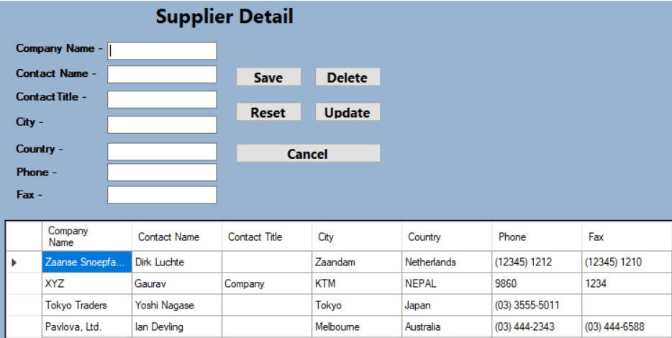

**This is Supplier Detail where the details of supplier of products is given. For example, Wai Wai noodles is sold in Nepal, its company name is CG group. Likewise we need to give the required information.**

**1)** Here, Save button works same as Customer and Product Table, where the data are stored in the database SQL server. Empty data doesn’t accept here except FAX, it can be null.

**2)** Reset clears all the filled data in the boxes.

**3)** Delete button is like other tables.

**4)** Update works as other tables.

**5)** Cancel to exit the form.

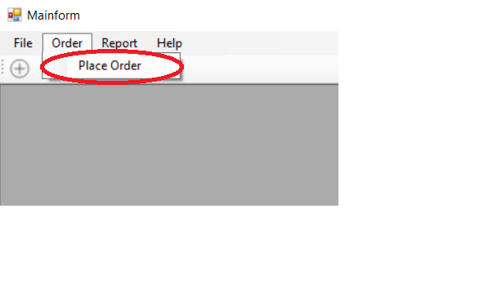Expand Order in the Main form and go to Place Order.

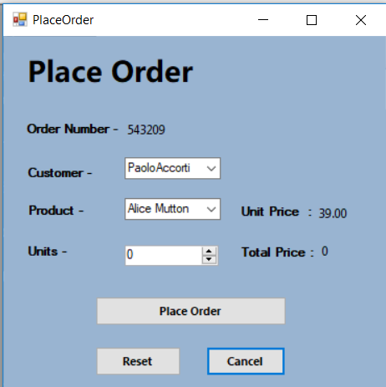 **This is the page you place the order for the different kinds of product.**

**1)** Order Number is a Primary Key where it is always different.

**2)** Select your name, if not go to Customer table and give your details.

**3)** Select the Product you want to order.

**4)** Units means number of product you wanted to order.

**5)** Unit price is shown automatically when you increase the Units. If it is 0, original price of one product is shown. Here, Total price = Unit price * Units.

**6)** Finally, click it to place the order.

**7)** Click Reset to reset the data.

**8)** Press Cancel to exit the form.

Here, every data automatically saves when the order is done. Total sales of a Customer increases. Number of order of a Customer/Product.

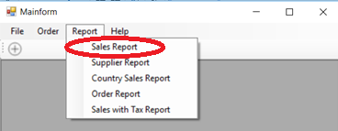For Reports of the appropriate management information, expand Report and Sales Report for the Total Sales Product Wise within a date of range.

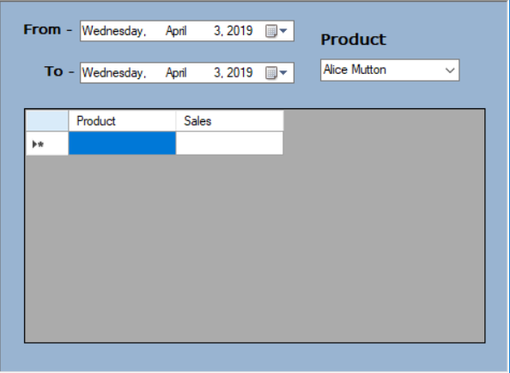

**1)** Select the date range.

**2)** And select the Product.

**3)** Valid range of date and Product shows the Total Sales in this Grid.

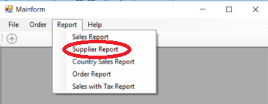Go to Supplier Report for the overall information of date of purchase and sale with Customer Name.

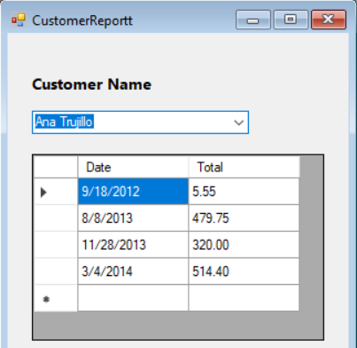

**1)** Select the Customer Name.

**2)** It shows date of purchase and its total sale.

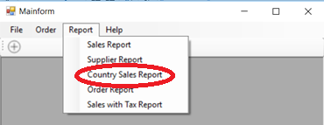

Go to Country Sales Report for the information of Total Sales within a Country.

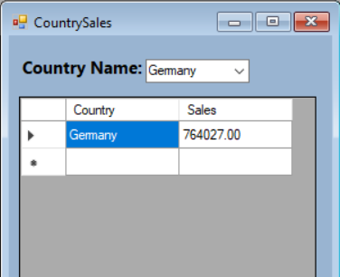

**1)** Select the Country Name.

**2)** It shows its total sales within the Country.

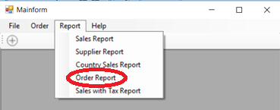Go to Order Report for the total number of orders made within a certain year including Customer Name.

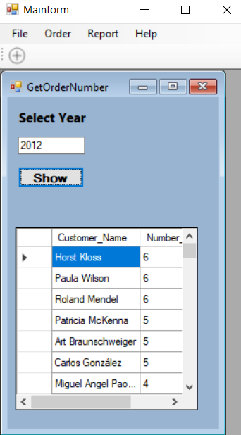

**1)** Given the year for following reports.

**2)** Click button ‘Show’ to display the information in

(3), data grid view.

Go to Sales with T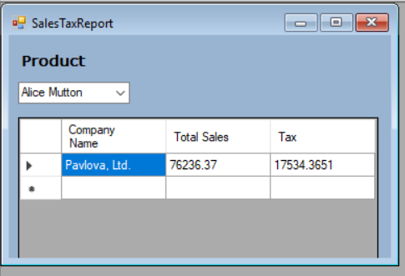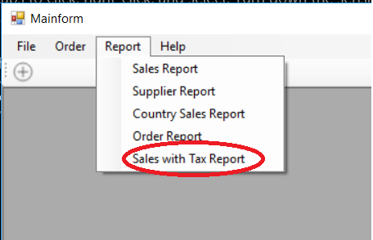ax Report.

**1)** Select the Product.

**2)** It will show the Company Name, Total Sales and Tax for selected Product.

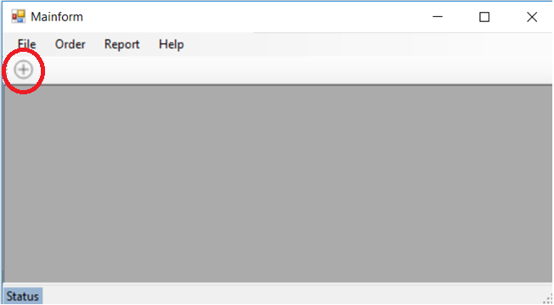‘+’ Sign is for creating new users; for Administrator.



**1)** Give your unique Username because it includes a

Unique key.

**2)** Give your email address, its compulsory.

**3)** Provide a strong password with symbols, numbers

for secured account.

**4)** Click Sign Up to create a new user.

**5)** After creating, click Go to Login page to login.

Flowchart**:**

Flowchart of Login button for Login page.



Flowchart of Sign Up button for Create user form.



Flowchart for all the Save button.

Flowchart for Delete button.



Flowchart for Update Button.



**\***Assessing future improvements **that may be required to ensure the continued effectiveness of the database system.**

As I have completed the project to make a application for an International vendor with many clients all over the World. I made this application so that all their clients would be able to store data on it. Data are related to the products that has been bought from any of its Suppliers and Customers located in different countries that can make orders.

I am suggesting some future improvements for this application in my own view. I have used simple design in it. Designing with a cool pictures, background would bring good environment in the application. The application could have include more interesting features like ‘Forget password’, when the user forget their password, their Email could be useful to reset the password. Keeping Feedback page would be better, users can share their opinions on our application. There should be features of login as guest too, but whenever the user tries to order, they must require to login.

I will be working on these future improvements as I will learn it.

## Conclusion

Finally, I have finished part III with testing the whole application. I have included user documentation where Customer are guided step by step. Similarly, flow chart of the system is also include which may help in understanding of the application. Also, I provided the further improvements methods for this application.

**References**

**Book**

The Ultimate Beginner’s Guide to SQL & Database.

[Programming .NET Security: Writing Secure Applications Using C# or Visual Basic .NET](https://www.amazon.com/Programming-NET-Security-Writing-Applications-ebook/dp/B0043EWTXA/ref=sr_1_2?keywords=visual+studio+c%23&qid=1555299008&s=books&sr=1-2-catcorr).